//QUESTION::1

#include<stdio.h>

int main()

{

int n, sum = 0;

printf("Enter the number of elements in the array: ");

scanf("%d", &n);

int arr[n];

printf("Enter the elements of the array:\n");

for (int i = 0; i < n; i++)

{

scanf("%d", &arr[i]);

}

int *ptr = arr;

for (int i = 0; i < n; i++)

{

sum += *(ptr + i);

}

printf("Sum of elements in the array: %d\n", sum);

return 0;

}

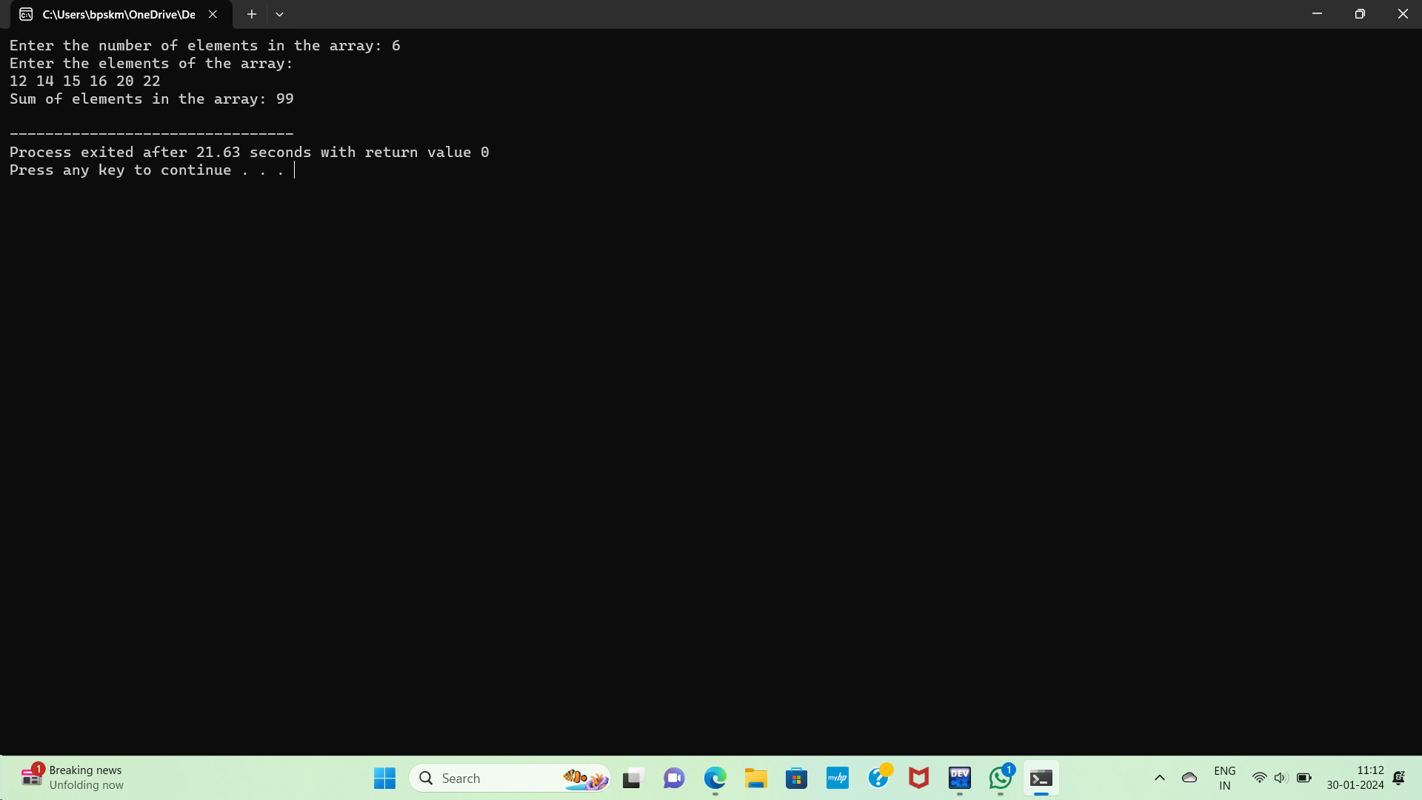

QUESTION::2

#include<stdio.h>

void swap(int *,int *);

int main()

{

int a=666,b=875;

printf("Before swapping a=%d b=%d\n",a,b);

swap(&a,&b);

printf("After swapping a=%d b=%d\n",a,b);

return 0;

}

void swap(int *x,int *y)

{

int temp;

temp = *x;

*x = *y;

*y = temp;

}

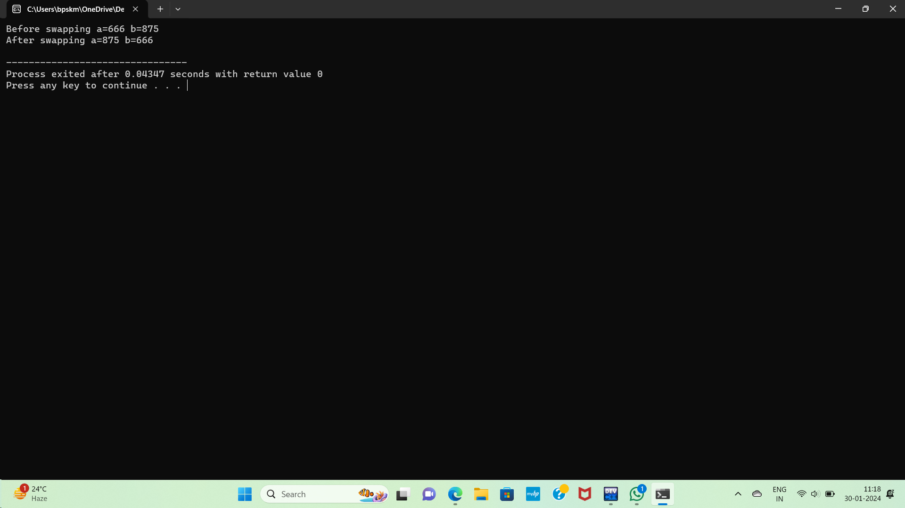

QUESTION:😊

#include<stdio.h>

#include<string.h>

void reverseString(char* str)

{

int l, i;

char *begin_ptr, *end_ptr, ch;

l = strlen(str);

begin_ptr = str;

end_ptr = str + l-1;

for (i = 0; i < (l - 1) / 2; i++)

{

ch = *end_ptr;

*end_ptr = *begin_ptr;

*begin_ptr = ch;

begin_ptr++;

end_ptr--;

}

}

int main()

{

char str[100] = "sathish";

printf("Enter a string: %s\n", str);

reverseString(str);

printf("Reverse of the string: %s\n", str);

return 0;

}

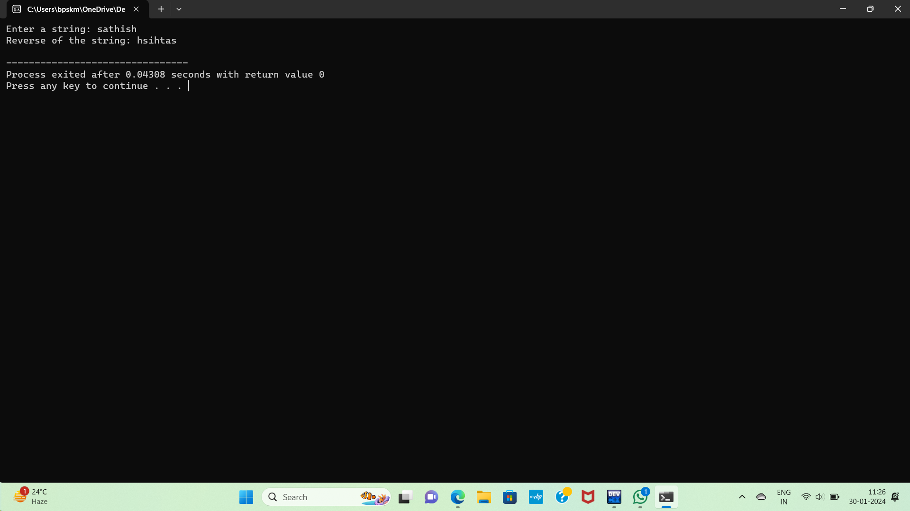

QUESTION::4

#include<stdio.h>

double power(double base, int exponent)

{

double result = 1.0;

for (int i = 0; i < exponent; i++)

{

result *= base;

}

return result;

}

typedef double (*PowerFunction)(double, int);

int main() {

double base, result;

int exponent;

PowerFunction powerPtr = &power;

printf("Enter the base: ");

scanf("%lf", &base);

printf("Enter the exponent: ");

scanf("%d", &exponent);

result = powerPtr(base, exponent);

printf("Result: %.2f ^ %d = %.2f\n", base, exponent, result);

return 0;

}

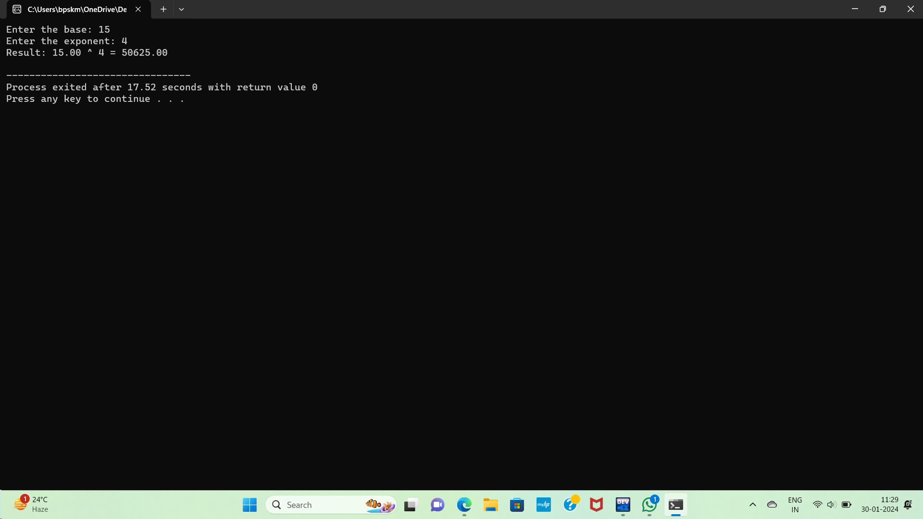

QUESTION::5

#include<stdio.h>

#include<stdlib.h>

int main()

{

int rows, cols;

printf("Enter the number of rows: ");

scanf("%d", &rows);

printf("Enter the number of columns: ");

scanf("%d", &cols);

int **matrix = (int **)malloc(rows * sizeof(int *));

if (matrix == NULL)

{

fprintf(stderr, "Memory allocation failed. Exiting.\n");

return 1;

}

for (int i = 0; i < rows; i++)

{

matrix[i] = (int *)malloc(cols * sizeof(int));

if (matrix[i] == NULL)

{

fprintf(stderr, "Memory allocation failed. Exiting.\n");

for (int j = 0; j < i; j++)

{

free(matrix[j]);

}

free(matrix);

return 1;

}

}

printf("Enter the elements of the 2D array:\n");

for (int i = 0; i < rows; i++)

{

for (int j = 0; j < cols; j++)

{

scanf("%d", &matrix[i][j]);

}

}

printf("The 2D array is:\n");

for (int i = 0; i < rows; i++)

{

for (int j = 0; j < cols; j++)

{

printf("%d ", matrix[i][j]);

}

printf("\n");

}

for (int i = 0; i < rows; i++)

{

free(matrix[i]);

}

free(matrix);

return 0;

}

